

**KABARAK UNIVERSITY**

**SCHOOL OF COMPUTER SCIENCE AND BIOINFORMATICS.**

**DEPARTMENT OF COMPUTER SCIENCE AND IT.**

FINAL PROJECT.

PROJECT TITLE: **CLASS ATTENDANCE USING QR CODE.**

**A Project Documentation Submitted in The Department of Computer Science and IT in partial fulfilment of the degree of Computer Science.**

**MUSHINDI. E. RACHEL. A. INTE/MG/1079/09/20.**

**SUPERVISOR: MR. MOCHOGE**

### DECLARATION

**Declaration by the student.**

I hereby declare that all the information presented in this document has been obtained and presented in accordance with academic rules and ethical conduct.

**NAME:** MUSHINDI. E. RACHEL. A

**REG NO:** INTE/MG/1079/09/20

**Signature** **Date**

**............................... .....................................**

**Declaration by the lecturer.**

**NAME:** MR. CLEOPHAS MOCHOGE

This document has been written and submitted with my approval.

**Signature** **Date**

**............................... .....................................**

### DEDICATION

I dedicate this project to my beloved mother who has been a great inspiration and great encouragement throughout my entire course of study.

### ACKNOWLEDGEMENT

I would first want to thank the Almighty God for guiding me throughout my course of study. I would also like to extend my gratitude to my lecturers who have impated much knowledge in me which has helped me throughout the project.

### ABSTRACT

There has been a major concern in taking class attendance in most of the Kenyan universities. Some students opt to skip classes and ask their friends to sign the class attendance in their absence. This has made quality assurance in taking class attendance challenging. Some lecturers have also opted to call the attendance name by name after they have finished lecturing. This is time consuming and can also be tiresome, considering a class with many students. Technology has evolved and there is always a solution for every problem. Therefore, coming up with a web based class attendance system using QR code, will be a solution for the mentioned problem. In as much there is an option of using biometrics which can be expensive to implement, this solution also considers the universities that are still growing. Most universities uses the attendance sheet, therefore, the solution also aims to eradicate paper work. Embracing the system will save time, work load and also increase safety of data. Example, misplaced or damaged attendance sheet. The proposed system will be intergreted into the student‘s university portal, where every student will login to their portal and scan the QR code provided by their lectures for every class. The system will also be able to tally the student‘s attendance at the end of the semester and determine whether the student can sit for their end of semester examinations or not. For its implementation, django framework and a QR code generator will be used. The limitations of the system is that every student requires a smartphone, another limitation is that the QR code scanning needs enough lighting. Poor QR code printing and distribution can also be a challenging that, if the QR code is poorly printed, it can be hard to be scanned.

**Table of Contents:**

DECLARATION II

DEDICATION III

ACKNOWLEDGEMENT IV

ABSTRACT V

CHAPTER ONE 2

INTRODUCTION 2

1.1 BACKGROUND OF THE STUDY 2

1.2 STATEMENT OF THE PROBLEM 2

1.3 PURPOSE OF THE STUDY 2

1.4 OBJECTIVES 3

1.4.1 GENERAL OBJECTIVES 3

1.4.2 SPECIFIC OBJECTIVES 3

1.5 JUSTIFICATION 3

1.6 SCOPE/LIMITATION 4

1.6.1 Geographical scope 4

1.6.2 Theoretical scope. 4

1.6.3 Modules. 5

1.6.4 Limitations of the study 5

CHAPTER TWO 6

LITERATURE REVIEW 6

2.1 INTRODUCTION 6

2.2 REVIEW OF RELATED LITERATURE 6

2.3 THEORETCAL FRAMEWORK 9

2.4 CONCEPTUAL FRAMEWORK 9

2.5 IDENTIFICATION AND KNOWLEDGE GAP 10

CHAPTER THREE 12

RESEARCH METHODOLOGY 12

4.2 INTRODUCTION 12

3.2 RESEARCH DESIGN 12

3.2.1 Rationale for a Mixed-Methods Approach: 12

3.2.2 Connection to Research Objectives: 12

3.3 LOCATION OF STUDY 13

3.4 TARGET POPULATION 13

3.5 SAMPLE AND SAMPLING PROCEDURES. 13

3.6 DATA COLLECTION PROCEDURES 14

DESIGN DIAGRAMS. 15

3.8 ETHICAL CONSIDERATIONS 16

CHAPTER FOUR 17

SYSTEM IMPLEMENTATION AND DEPLOYMENT 17

4.1 INTRODUCTION 17

4.2 SYSTEM ARCHITECTURE 17

4.3 FRONT END DEVELOPMENT 17

4.4 USER INTERFACE DESIGN 19

4.5 USER INTERFACE MODULES 20

4.6 BACK END DEVELOPMENT 21

4.7 DEPLOYMENT METHODS 23

CHAPTER FIVE 24

RECOMMENDATION AND CONCLUSION 24

5.1 RECOMENDATION 24

REFERENCES 26

APPENDICES 27

**List of Figures:**

Figure 1: Conceptual Framework Digram. 10

Figure 2: Context Diagram 16

Figure 3: DFD Diagram 16

Figure 4: Use-Case Diagram 17

## CHAPTER ONE

## INTRODUCTION

### BACKGROUND OF THE STUDY

In traditional education system setting, taking class attendance has been an important aspect. The methods of tracking attendance involved, manual process of the students

signing the attendance sheet or the instructors calling out names. These methods have served purpose over years but they still have some limitations and challenges.

The manual attendance tracking is time consuming, consider a class that has over a hundred students. Instructors also struggle to complete the process of taking attendance efficiently, human error cannot be ignored. Some students have failed to uphold loyalty in signing the attendance. They have opted to skip classes and ask their friends to sign for them. These inaccuracies in the attendance records have brought lack of fairness in assessment and also class management.

### STATEMENT OF THE PROBLEM

Manual attendance tracking is tedious and time consuming which often leads to inaccurate records and disruption of classes.

### PURPOSE OF THE STUDY

The primary focus of the research is to explore the implementation of QR code being integrated in the students portal as a technological solution to manage class attendance.

The study seeks to contribute to the enhancement of attendance tracking process in educational institutions by harnessing the potential of QR codes through the objectives mentioned.

### OBJECTIVES

### GENERAL OBJECTIVES

1. To ease the process of taking class attendance.
2. To ease overall class attendance analysis and generation of attendance reports.
3. To reduce paper work associated with taking class atttendance.

### SPECIFIC OBJECTIVES

1. To design and develop a QR code-based attendance tracking system that is user friendly and Integrates seemingly with existing student management system.
2. To develop a system that will be reliable and accurate in taking class attendance.
3. To develop an a time saving and cost-effective attendance system.

### JUSTIFICATION

1. Efficiency and time saving: Manual attendance tracking methods tend to take more time and disrupts the learning process. QR code-based system have the potential to streamline the attendance-taking process, allowing instructors to optimise the use of valuable class time.
2. Data Analysis and Insights: QR code-based systems can generate valuable attendance data that can be used for deeper analysis. This can offer insights into attendance patterns, student behaviours and potential early interventions for struggling students. The system automates attendance records, facilitating audits and improving overall student management. This leads to more efficient resource allocation and decision-making.
3. Less paperwork: By transitioning to the digital attendance system, paperwork is reduced by eliminating the need for printing, distributing, and storing physical attendance sheets. This also eliminates human errors in the process of taking class attendance.
4. Alignment with digital learning environments: Educational institutions have increasingly embraced digital learning platforms and online resource, QR codes are a good fit for tracking attendance in these learning environments.
5. Accuracy and reliability: Traditional methods of taking class attendance is prone to errors, including inaccurate record-keeping and fraud. QR codes provide a technology driven solution that significantly reduces the margin for human error, ensuring more accurate attendance records. The technological solution also reduces fraud cases in taking class attendance, where a student signs in for another student who has not attended the lecture.
6. Cost-Effective and time-saving solution: QR code technology is cost effective as it does not require extensive hardware and software investments, making it accessible to a wide range of educational institutions. Manual class attendance tracking would take much time compared to using the QR code system which will give lecturers valuable time to finish their classes.

### SCOPE/LIMITATION

### Geographical scope

The QR-Code based attendance system will target student and lecturers of KABARAK University and also the higher learning institutions in NAKURU COUNTY and KENYA at large, therefore I am confident that the sample population will provide adequate feedback to facilitate the development of the application.

### Theoretical scope.

Theoretically, the QR-Code based attendance management system is to be tested by students and the lecturers of the KABARAK University fraternity who will participate in a controlled environment with security in order to test its different features and functionalities to ascertain that it is functioning correctly before it can be rolled out for use in an actual education environment.

### **Modules**.

1. **Administrator**: The role of the administration is to add students and staff to the system. The can also update the records in the database. They can also view attendance reports.
2. **Students**: These will be registered to the system by the administrators and will be required to take their class attendance for their registered units by scanning the QR code provided by the lecturer.
3. **Staff (Lecturers)**: These are the people who conducts the lessons. They are able to generate the QR code for taking class attendance from the system and can also view reports on class attendance to ensure attendance policy set by the institution is maintained.

### Limitations of the study

* Given the short duration of time, coming up with a fully functional system that meets the user requirements may be a challenge.
* It’s a one-way communication.
* Distrust and unfamiliarity. It can be unclear what the lecture is to do and tech-savvy lecturers and staff might not be comfortable to use the system.
* Requires internet connection.
* Can be inconvenient as QR codes require smartphones with the ability to scan.

## 

## CHAPTER TWO

## LITERATURE REVIEW

### INTRODUCTION

This chapter entails review of related literature which is a crucial area in the project whereby, I was able to identify some knowledge gap and of which I have included in my project.

### REVIEW OF RELATED LITERATURE

The QR code was invented in Japan by a development team led by Masahiro Hara for the company Denso Wave in 1994, just as automotive manufacturing technology was picking up steam. The requirements of strangely-shaped auto parts moving around factories at high rates of speed is fundamental to QR code history and Hara is widely credited as the creator of the QR code. QR Codes consist of black modules arranged in a square pattern on a white background. They are designed to decode the data quickly. It is quite easy to create and use these codes (Pons, 2011).

Since 2011, QR codes has been used in different forms. According to comScore MobiLens (2011), 1 out of 5 smart-phone owners in U.S. scanned QR codes. Canada and Germany both saw near 16% of smart-phone owners scanning QR codes in a month, while the UK and Spain (home to the most penetrated smart-phone markets) saw just 12% of their participants scanning QR codes.

It could be stated that studies on use of QR Codes in education were generally conducted in the field of mobile learning. Review of the related literature revealed that mobile devices were used while using QR Codes. According to So (2008), the most important aspect of mobile learning is the trilogy of ‘location independence’, ‘time independence’ and ‘meaningful content’. These three basic features are among characteristics of mobile learning, and they differ from e-learning and web-based learning due to these features.

According to Miangah in 2012, the rising speed of mobile technology is increasing and penetrating all aspects of human life. Therefore, this technology plays a vital role in learning different dimensions of information. Today, a clear shift from teacher-centered learning to student-centered learning causes students to find technology more effective and interesting than ever before.

In an experimental study conducted on the use of QR codes in education by Rikala & Kankaanranta, 2012, the views of 76 learners and of their teachers from four different-level schools were determined. The results of the study revealed that the learners were eager and motivated to use the QR codes. As for the their teachers, they approached cautiously to the use of QR codes in education and mentioned the likelihood of various difficulties to be experienced in relation to the preparation of lesson units and time. In addition, in the study, it was found that QR codes could motivate learners and draw their attention to class since these codes support learning and provide opportunities both for independent learning and for cooperative learning.

In another study carried out by McCabe and Tedesco in 2012, QR codes were used via smart phones for direct connection with the subjects within the scope of the course of mathematics. In the study conducted with 14 learners, all the learners reported positive views about the QR codes prepared for the course of mathematics. In such a course process, 83% of the learners stated that they prepared for the following lesson better and did their homework more productively, and 67% of them stated that there was an increase in their course marks and that they found it easy to use QR codes. In addition, as revealed by the most important finding obtained in the study, 83% of the learner experienced less stress when they studied for the lessons with the help of QR codes. According to the learners, the reason was that it was instantly possible to access the necessary information via QR codes without having to ask their peers or teachers. Not to mention Hernández-Julián & Peters (2012), in their study conducted to compare doing homework online with doing homework on paper, found that an electronic environment could make it easier to access an instructional material and that it did not significantly influence learning.

Everyone’s phone can scan them because cameras are ideal optical two-dimensional scanners. That makes them the perfect choice for a wide array of customer-facing content, like [QR code menus](https://www.sproutqr.com/blog/qr-code-menu) and [QR codes on tables](https://www.sproutqr.com/blog/qr-code-on-table) in bars and restaurants. They can also store large amounts of data, which makes them ideal for all sorts of [QR code marketing](https://www.sproutqr.com/blog/qr-code-marketing). They’re easy to create and maintain. Masahiro Hara didn’t expect his invention to change the world. But look at the [QR code statistics](https://home.binwise.com/guides/qr-codes-for-bars-restaurants), He did.

*Related systems*

1. **Biometric Attendance System -** A biometric attendance system essentially verifies the identity of the employee and captures one’s time of entry and exit using his or her fingerprint. Such systems are very popular today and for good reasons. This prevents any chances of buddy punching which leads to time leakages that can affect the [productivity of an organization](https://www.peoplehum.com/blog/best-practices-for-employee-productivity) as a whole. Biometric systems are usually integrated with other systems to convert the data into [lucid reports](https://www.peoplehum.com/blog/hr-reports-all-you-need-to-know). This can be done easily. Such systems have also been found to be extremely cost-effective as there are no-cost heads apart from the actual biometric machine itself.
2. **GPS-based Attendance System** - Global Positioning System, or GPS, enables us to determine a person's location and direction at any time, any place on Earth. In terms of knowing where humans are and how to go to other areas, people still.
3. **Face Recognition Based -** The idea of finding human faces in referenced photographs or videos is known as face detection. A face recognition system is a type of tech that can compare face images from a video or photograph to a database of known and unknown faces. The Management System, was developed by Smitha to develop an organized classroom attendance system using face recognition methods through facial ID. a camera, it finds faces and then recognizes them. The system is split into two parts: facial recognition and detection. Using the Local Binary Pattern Histogram (LBPH), the system will identify faces of students in the live-streamed video from the class and, if the recognized face is found in the database, will mark their attendance.
4. **Android-Based Authorized ID and Password Android OS -** was developed mainly for touch. It is based on a slightly different version of the Linux kernel and other open-source applications. You can be prompted to sign up or sign in each time you use an android-based smartphone and visit an application or website. Typically, a login/password creation request can be made for you. Now that this procedure is so popular, some users may register their accounts without giving attention to their password because it has practically become part of the routine.

### THEORETCAL FRAMEWORK

A QR code is a two-dimensional code consisting of bars. The QR Code attendance management system is to be tested by students and the lecturers of the Kabarak university fraternity who will participate in a controlled environment with security in order to test its different features and functionalities to ascertain that it is functioning correctly before it can be rolled out for use in an actual education environment.

### CONCEPTUAL FRAMEWORK

In the development of a QR Code Based Attendance System, a conceptual framework serves as a roadmap for the entire project and outlines the objectives, goals, and expected outcomes of the system, as well as the necessary inputs and processes required to achieve these outcomes.

A QR code-based attendance system’s conceptual framework can be used to pinpoint the critical elements that influence the effectiveness and efficiency of the system. It can also be beneficial to define a precise set of requirements for the system, including the kinds of data to be gathered and the analysis techniques to be employed.

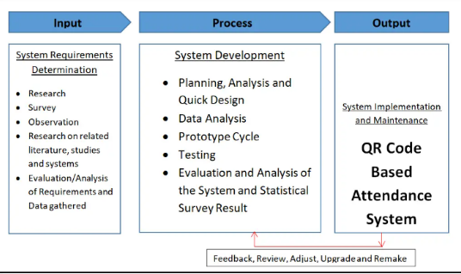

Figure 1: Conceptual Framework Digram.

### IDENTIFICATION AND KNOWLEDGE GAP

**QR-Code based attendance management system**

This project seeks to bridge the existing gap by integrating reliable data/database management, providing a range of reliable options to the administration, students and lecturers/staff in the University through an aesthetically pleasing system that will improve the user experience and also help the institution maintain the policies for class attendance.

Moreover, since the COVID-19 pandemic, many institutions of higher learning is tremendously embracing technology and it’s time for class attendance to follow suit. By going the QR-Code route for attendance, the institution is able to ensure a healthier trend of 100% class attendance and with ease. Second, it will have another channel to also ensure that students under the long-distance academic program also meet the class attendance policy set by the university. Thirdly, without any doubt, the lecturer will be able to simply generate attendance report without having to carry around sheets of papers for every course attended. Here are other advantages the qr-code based system will offer:

* **Cost effective**  
  QR codes don’t require any special training to make or use and since you can store a lot of information, you can reduce cost of printing attendance sheets. Redirecting to the attendance to be signed for the specific unit.
* **Customizable and trackable.**

QR code have the capability of holding a lot of information, so you can you’re rarely limited by the length of your URL.

Plus, since it links to an online platform you may be able to monitor and analyse data.

* **Fast**  
  With the rise of almost 90% of people owning smartphones especially in higher learning institutions, has made use of QR codes faster and easier. QR codes are tailored to smartphone usage, making scanning faster than typing a URL in or waiting to sign a sheet by pen.
* **Reliable**  
  QR codes are scannable from multiple angles, and even hold their information if the QR code is damaged. Much easier to use than paper-based attendance sheets.
* **Data Analysis and Insights**

QR code-based systems can generate valuable attendance data that can be used for deeper analysis. This can offer insights into attendance patterns, student behaviours and potential early interventions for struggling students.

* **Alignment with digital learning environments**

Educational institutions have increasingly embraced digital learning platforms and online resource, QR codes are a good fit for tracking attendance in these learning environments.

**Existing System over Proposed System.**

The proposed application seeks to simplify the lengthy procedures involved on a lecture to lecture basis for both the lecturer and their students of the institution. The stages involved in the registration and signing process must be reduced to nearest minimum if it is to be faster and more convenient. The crude way of signing attendance using paper-based processes are time consuming and expensive. The Lecturer is rest assured of authentication and availability of the students’ attendance available in the database at the end of every semester.

**Challenges:**

* The process is prone to error since students have been found to sign for their peers therefore accuracy is lost.
* Transfer of signed attendance sheets information to other systems for analyses is very tedious and time consuming.
* Since attendance is made on paper sheets, the same is likely to get lost and students requested to sign in again. This allows students who did not show up for the lesson earlier to sign in as well.

## CHAPTER THREE

## RESEARCH METHODOLOGY

### INTRODUCTION

This chapter entails the methods and techniques that were used during data collection for the study.

### RESEARCH DESIGN

In pursuit of a comprehensive understanding, this research adopts a mixed-methods design that seamlessly integrates both qualitative and quantitative methodologies. By combining these two approaches, the study aims to achieve a more nuanced exploration of user perspectives and a deeper analysis of potential impacts associated with the system.

### Rationale for a Mixed-Methods Approach:

The decision to employ a mixed-methods approach stems from the nature of the study. By combining qualitative and quantitative data collection and analysis, the study aims to not only quantify the effectiveness and usability of the system but also delve into the nuanced experiences, perceptions, and potential challenges faced by users.

### Connection to Research Objectives:

This mixed-methods design is intricately tied to the specific objectives outlined in Chapter One. The qualitative component, through interviews and open-ended survey questions, has facilitate a deeper exploration of user expectations and concerns. On the other hand, the quantitative component, utilizing structured surveys and system usage metrics, aims to quantify the system's impact on attendance tracking efficiency and overall user satisfaction.

### LOCATION OF STUDY

The focal point of this research is Kabarak University, where various stakeholders including students, lecturers, and administrators actively participated in shaping the contours of this study. The choice of Kabarak University as the study location offers a microcosm of the academic environment, enabling a detailed examination of the system's applicability and effectiveness.

### TARGET POPULATION

The target population for this case study comprises students, lecturers, and administrators within Kabarak University. This demographic encapsulates the key players in the academic environment and aligns with the study's focus on understanding the perspectives and potential impacts of the system within the university setting.

### SAMPLE AND SAMPLING PROCEDURES.

1. **Simple random sampling:** I used this sampling technique whereby I chose random students within Kabarak University to participate in the data collection. It is reliable because everyone had a probability to participate. The approach helped to capture a broad spectrum of perspectives across various academic disciplines.
2. **Systematic sampling:**  I also applied this technique whereby students were selected at regular intervals from the class attendance list. Although time-consuming, systematic sampling ensures a structured and evenly distributed representation.

### DATA COLLECTION PROCEDURES

1. **Observation**

I have been doing a continuous observation in my class and I have gathered insightful data that has directly impact my project development. It halped me to be up to date with emerging changes that has improved my project.

1. **Questionnaires**

I used questionnaires that was designed with precision, incorporating a mix of open and closed-ended questions. They were distributed among the target sample group that comprises of students, lecturers, and administrators to gather comprehensive insights into potential user expectations and concerns of the system. The use of questionnaires in collecting data collection has helped to serve users’ needs better through the system.

1. **Interviews**

I conducted open-ended interviews, this involved one-on-one conversation with different persons within the location of the study. I was aiming to understand potential user attitudes towards the system. It also uncovered expectations, perceived challenges and the overall reception of the system

### DESIGN DIAGRAMS.

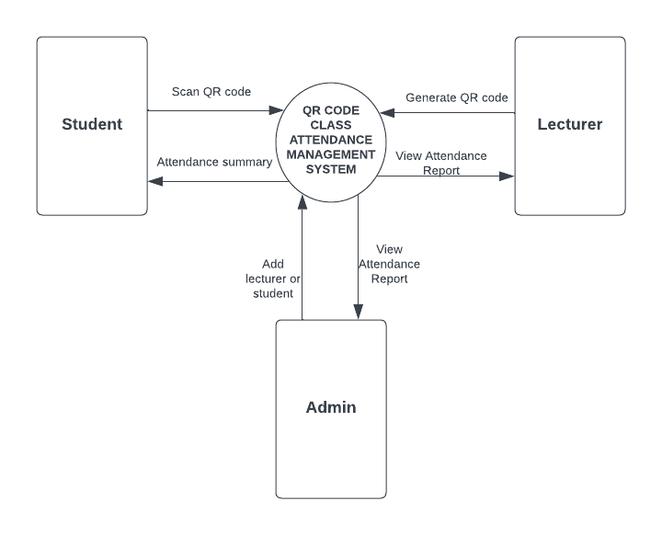

Figure 2: Context Diagram

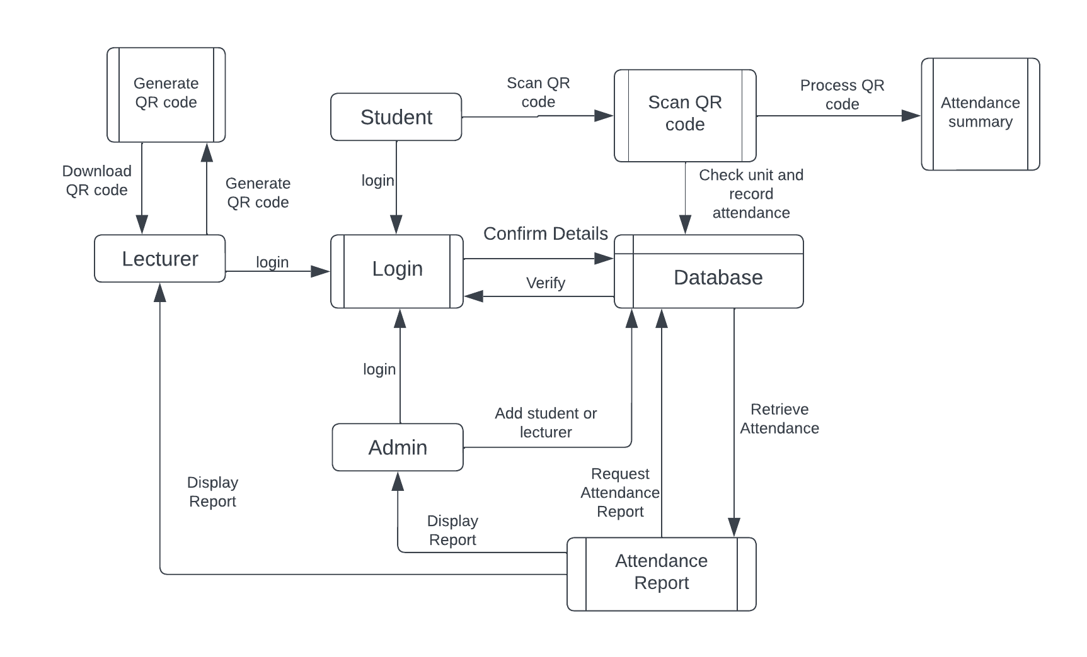

Figure 3: DFD Diagram

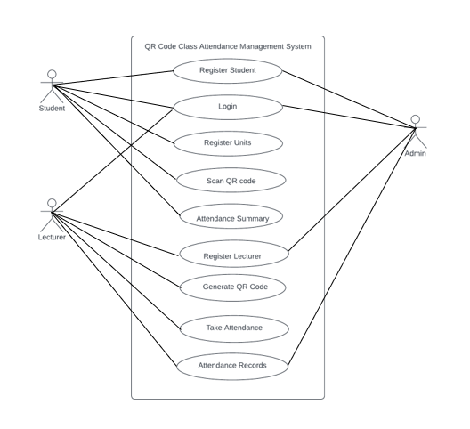

Administrator

Figure 4: Use-Case Diagram

### ETHICAL CONSIDERATIONS

Data collection process ensured individual privacy is protected. Only necessary information was collected and it was used solely for the development of the system.

During data collection process, I had to obtain informed consent from individuals who participated in the study and clearly communicate how I was going to use the data.

The system also ensures robust security measures to protect personal data. It is built with authentication and authorization mechanisms in order to protect personal information.

## CHAPTER FOUR

## SYSTEM IMPLEMENTATION AND DEPLOYMENT

### INTRODUCTION

The implementation and deployment of the Attendance Management System using QR code marks a crucial phase in its development lifecycle. This chapter details the systematic approach taken to bring the system from conception to operational deployment.

### SYSTEM ARCHITECTURE

The System follows a modular architecture, comprising three main modules: Admin, Lecturer, and Student. Each module has specific functionalities tailored to the roles of administrators, lecturers, and students.

The system architecture is based on a client-server model, with clients interacting with the system through a user interface (UI) while the server manages data processing.

The presentation layer, or front end, consists of user interfaces tailored for administrators, lecturers, and students. It includes login forms, dashboards, and attendance recording interfaces.

### FRONT END DEVELOPMENT

In the front end development phase, I focused on a user-friendly interface with different technologies.

Code Extracts:

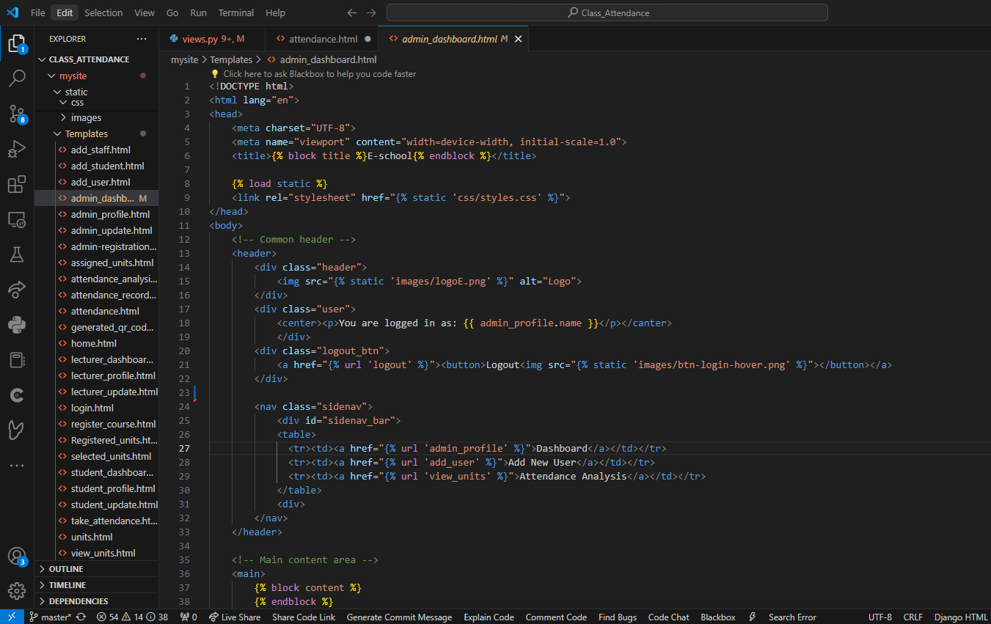

This is the front end implementation of the admin dashboard.

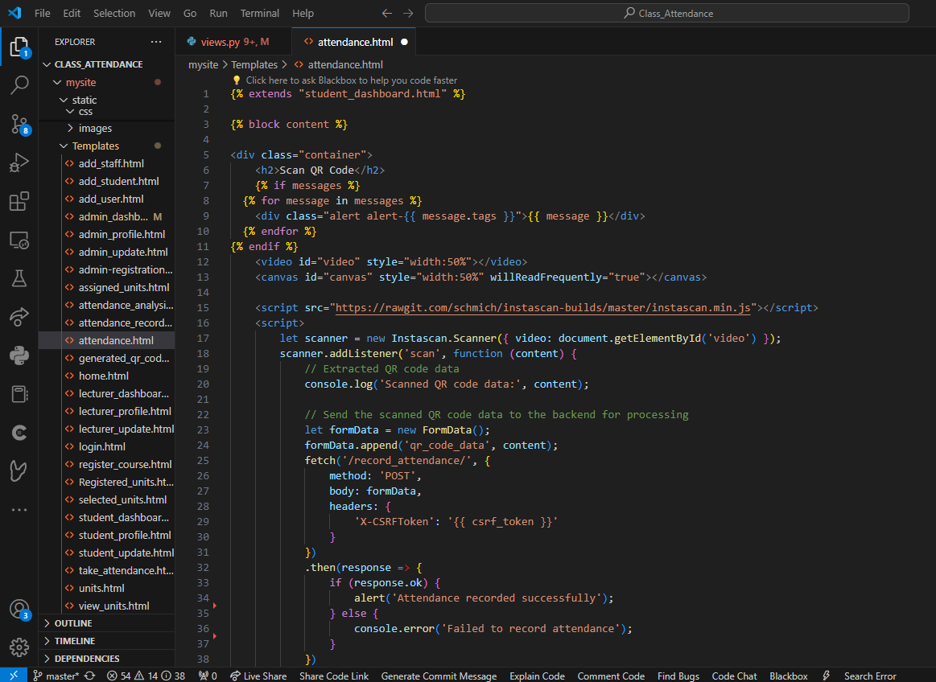

Attendance.html is the front end development part for scanning the QR code in order to record attendance. JavaScript is used to implement QR code scanning.

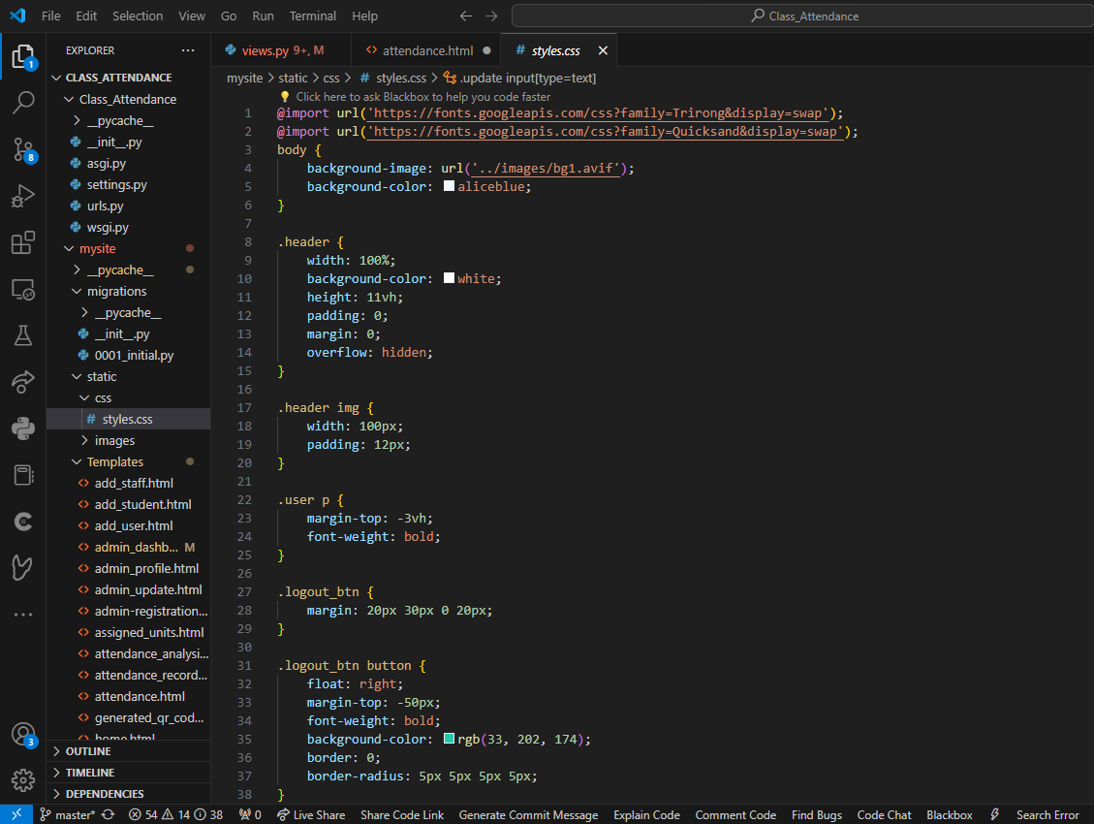

This is the styling page, contains the styling of the entite project.

Technologies used:

* HTML – Used for structuring the web pages.
* CSS – Utilized styling and layout design.
* JavaScript – Implemented for client-side interactivity and dynamic behavior.

### USER INTERFACE DESIGN

This phase has focused in creating visually appealing interfaces that align with the project’s goals and target audience. The UI design is tailored to provide a seamless experience for users, allowing them to perform their respective tasks efficiently.

Admin Interface:

The admin interface offers comprehensive tools and functionalities for administrators to view attendance records, and perform administrative tasks like adding users to the system.

Lecturer Interface:

The lecturer interface empowers lecturers to view attendance records of the units they are assigned, and generate QR codes for attendance tracking

Student Interface:

The student interface provides a user-friendly experience for students to register for units, view unit details, and record attendance

### USER INTERFACE MODULES

Login Module:

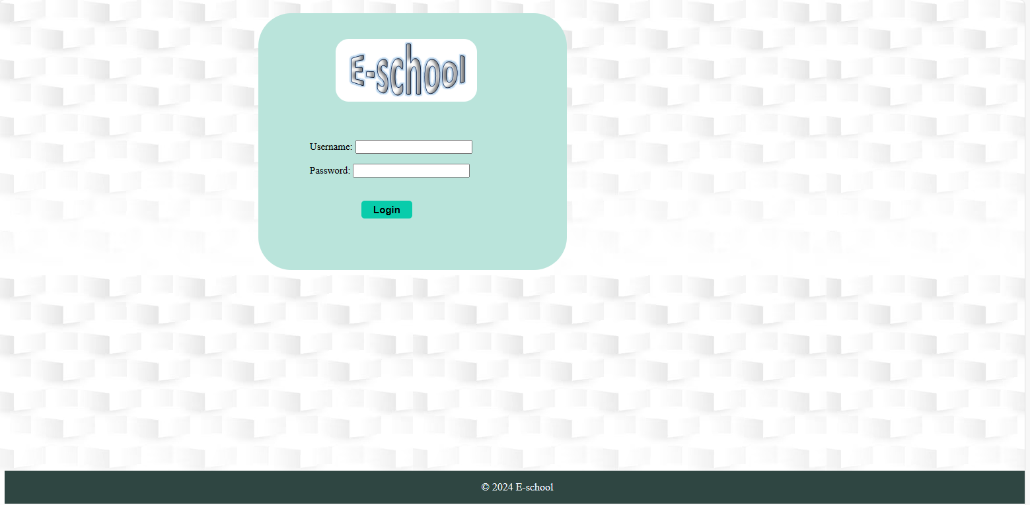

The login module provides the users with a form to enter their credentials and access the application in a secure way.

Dashboard Modules:

Student:

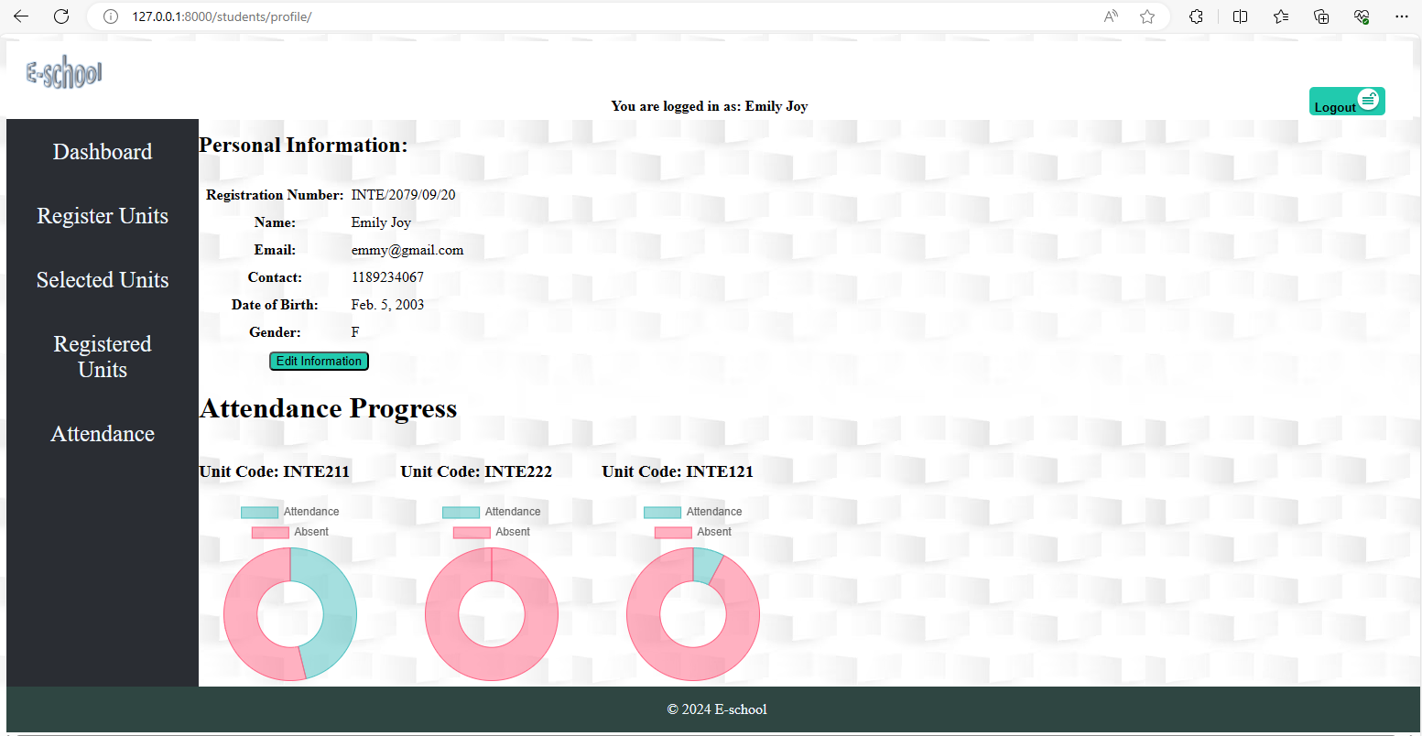

Lecturer:

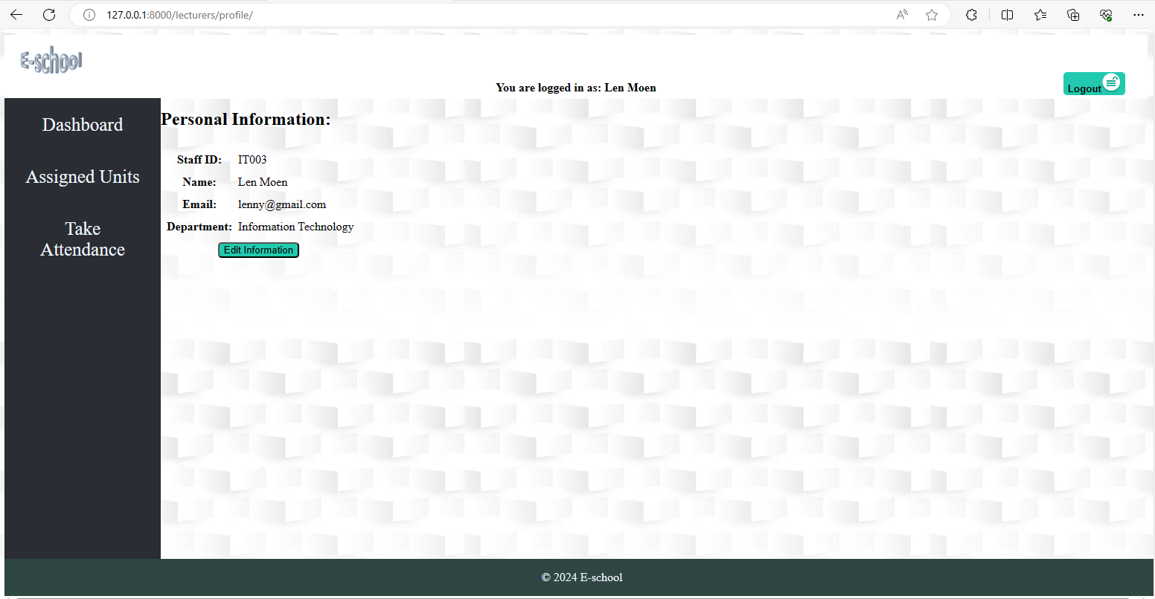

Admin:

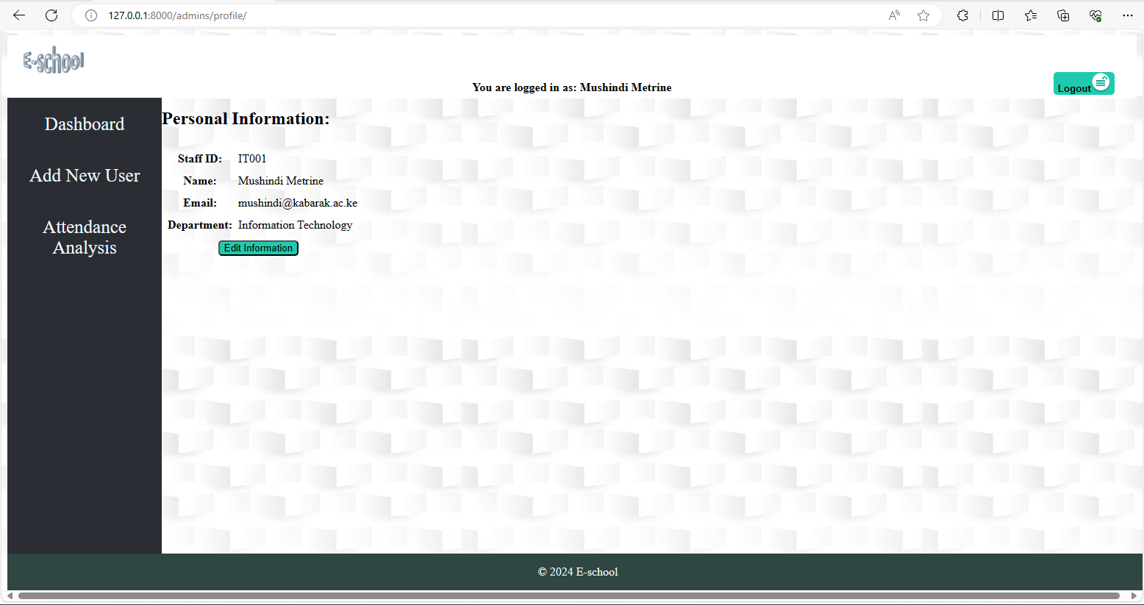

The dashboard module displays an overview of relevant data and features, allowing users to navigate to different sections of the application.

### BACK END DEVELOPMENT

This phase focuses on building a robust server-side components to handle data processing.

Technologies used:

* Django – A python framework.
* SQLite3 – Selected as the database management system for its flexibility in handling data.

##### **Database Design Models**

The database design was carefully crafted to ensure efficient storage and retrieval of data to ensure efficient storage and retrieval of data while maintaining data integrity and consistency.

Entity-Relationship Diagram:

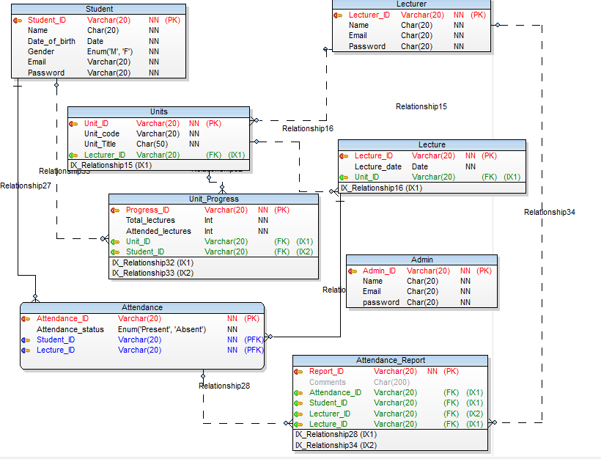

1. **Tables.**

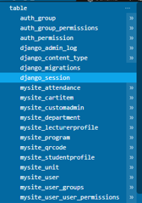

1. **Code Testing**

Methods used:

* Integration Testing: I conducted an integration tests to ensure seamless interaction between the different modules and services.
* End-to-End Testing: Performed end-to-end tests to validate the entire application flow and user scenarios.

### DEPLOYMENT METHODS

The System is deployed on localhost, which provided a convinient way to test its functionalities and ensure the features are working correctly.

Before deploying the system on localhost, the following prerequisites should be met:

Python and Django: Install Python and Django framework on the local machine.

Database: Set up a local database server (e.g., SQLite) for storing system data.

Dependencies: Install any necessary dependencies required by the system.

**Database Configuration:**

Configure the local database settings in the Django project settings file (settings.py). Update the database engine, name, user, password, and any other as per the local database setup.

**Database Migration:**

Apply database migrations to create database tables and schema. Use the following commands on the shell:

$ python manage.py makemigrations

$ python manage.py migrate

**Static Files Collection:**

Collect static files for the project (CSS, JavaScript, etc.) into one directory for serving. Use the following commands on shell:

$ python manage.py collectstatic

**Run Development Server:**

Start the Django development server to run the system locally. Use the following code:

$ python manage.py runserver

**Accessing the System:**

Open a web browser and navigate to http://localhost:8000 to access the System.

## CHAPTER FIVE

## RECOMMENDATION AND CONCLUSION

## RECOMENDATION

This system should be implemented in every university to improve efficiency in taking class attendance. Considering the system is digitized, there is less paper work required which reduces cost and eliminates human errors. The system brings order in student management whereby, a student cannot take attendance of the unit they have not registered for. Accountability is also covered in the system because, lecturers are not able to call of classes as they wish. The system keeps track on the lecture dates. On the other hand, the admin does not have to go through the hustle of doing attendance analysis based on the attendance sheets they have received, this is because the system enables them to view attendance analysis just with one click.

Overall, the system ensures effective and efficient students‘ class attendance management and provides instant insights.

* 1. **CONCLUSION**

In conclusion, the implementation of QR code technology in the attendance management system, streamlines the process, enhancing efficiency and accuracy. By providing administrators with robust attendance analysis report, it helps them make informed decisions and optimize resource allocation. The integration of QR codes opens doors for further innovation and improvements in tracking attendance. As technology continues to evolve, the system remains adaptable and poised to meet the evolving needs of an organization.

### REFERENCES

Hernández-Julián, R., & Peters, C. (2012). "What Do Grades Mean? The Relationship Between Community College Course Grades, Wages, and Field of Study." Research in Higher Education, 53(5), 507-538.

McCabe, J., & Tedesco, S. (2012). "QR codes as a teaching tool in a college mathematics course." Journal of College Science Teaching, 41(1), 72-78.

Miangah, T. (2012). "Mobile learning and mobile application usage: A glimpse of student self-reported reading habits." Journal of the Chinese Language Teachers Association, 47(1), 43-58.

Noor, S. A. M., Zaini, N., Latip, M. F. A., & Hamzah, N. (2015). "Android-based attendance management system." In 2015 IEEE Conference on Systems, Process and Control (ICSPC) (pp. 118-122). IEEE.

Rikala, J., & Kankaanranta, M. (2012). "QR codes in the classroom--A peek into the future of technology-enhanced language learning." ReCALL, 24(3), 322-337.

Smitha (not mentioned in the original document). Please provide more information or check the original source for the complete reference.

So, S. (2008). "The trilogy of mobile learning: Location independence, time independence, and meaningful content." In M. Ally (Ed.), Mobile Learning: Transforming the Delivery of Education and Training (pp. 3-14). AU Press.

Talip, B. A., & Zulkifli, M. Z. (2018). "Mobile attendance system using QR codes technology." Journal of Computing Technologies and Creative Content, 3(1), 1-3.

### APPENDICES

**WORKPLAN**

|  |  |  |  |  |  |
| --- | --- | --- | --- | --- | --- |
| Activities | September-October | October-November | November-End of November | January-February | March |
| Chapter One |  |  |  |  |  |
| Chapter Two |  |  |  |  |  |
| Chapter Three |  |  |  |  |  |
| Chapter Four |  |  |  |  |  |
| Chapter Five |  |  |  |  |  |

**Table 1: Workplan**

**BUDGET**

|  |  |
| --- | --- |
| **ITEM** | **AMOUNT** |
| Laptop/ Smartphone | `Ksh.25,000 |
| Internet services | Ksh.6,000 |
| System maintenance | Ksh.5000 |
| **Total** | **Ksh.36,000** |

**Table 1: Budget Evaluation**

**QUESTIONNAIRE**



